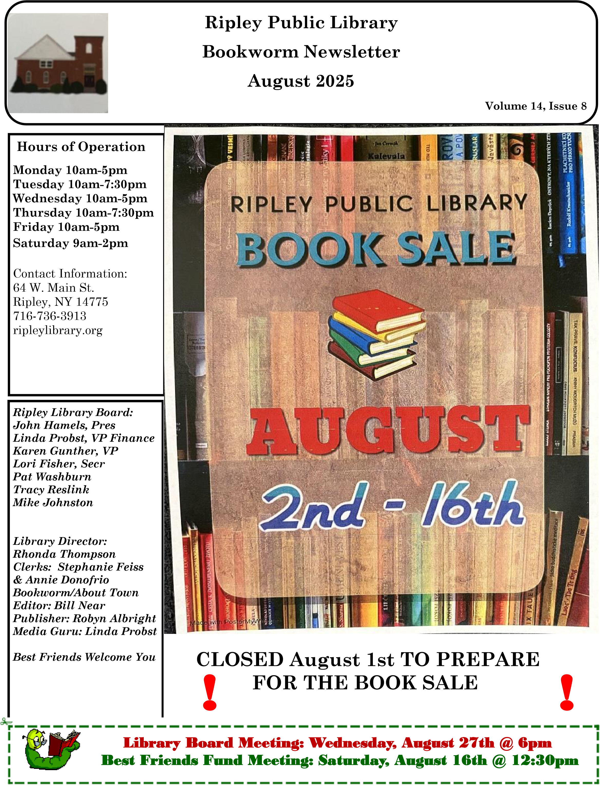
Volume 14 August 2025 ^{Page 2}
Coming up in August
  Library closed August 1st
  To Prepare for the Book Sale
Coming up in August
  Annual Book Sale August 2-16
Coming up in August
  Book Club
  Meets the 1st Monday of the month at 5:30pm Book:
  Glory Over Everything
  By Kathleen Grissom
Coming up in August
  Nutrition with Molly
  Thursday August 26th at 6pm
  Tuesday August 28th at 11am
Coming up in August
  Write Your Own Story
  With Mary Ellen Humphrey & Robyn Albright Saturday, August 23rd at 11am
Coming up in August
  Knitting & Crochet Group
  Every Tuesday at noon All levels welcome
Coming up in August
  Sewing Group
  Every Thursday at noon
  Quilters and sewers of all levels are welcome
Stay & Play
Tuesday mornings at 10:30am

Director’s Report—August 2025 We cannot survive on bake sales and book sales. Secondly, the capital project
Time to Say Good-bye
I took on revealed the damaged beam. Wow! August is here already. Very According to the contractor and the enhard to believe. I began my tenure here gineer who told us how to repair it, the in August of 2014. In some ways it building would have collapsed by now seems like a long time ago and in other and the library would no longer be ways it feels like yesterday. Writing here. This project also beautified our this article is rather bittersweet as it is old 19th century church and made it the last one I will write as your Library such a lovely and comfortable place to Director. I will retire on August 31, be. Thirdly, I feel I had a hand in mak-
2025. ing a difference in the atmosphere of
the library. The library is vibrant and
As many of you know, I have been conlively. Patrons from all over remark templating this move for a while now. about how welcoming the Ripley Li-
For eight years I have balanced two brary is. The library is now a place of jobs. This is getting a little tough and activity and community involvement, as we all know, I am not getting any from nutrition classes to vendor fairs, younger. I also have had two major surwe cover the gamut of everyone’s intergeries in two years. I believe it is time ests. There are many more accomplishto slow down. ments but they are too numerous to I have thought a lot about the changes mention here. the library has gone through since I
The hope I have is that everyone unstarted eleven years ago. We have done derstands that everything I did here so much for so many people over the was with the library and the communiyears. To get an idea of much the lity in mind. We now have a beautiful library has done, just come in and look brary. This is the result of a great deal through the old Bookworm newsletters of work done by many people and the and see the changes for yourself. Then
dedication of those who come often to you will understand how this library our library or support the library by has really become a community center. other means. My immeasurable thanks
As my time here is winding down, I to all of you who have spent your time have been reflecting on how much this and money to make our library what it place means to me and how much I is today. You folks are the best and I hope it means to our town.
will never forget you.
The accomplishments I am most proud
In closing I will ask for everyone to of are first of all, becoming a school dis-
trict library. This has allowed us the Continued on Page 4 funds needed for our library to thrive.

Page 4
continue to support the growth neces- needs of the community. sary for our library to continue. Allow
A little girl recently came to the li-
the library to change with the changing brary and made a sign and showed it to
of times. Allow the noise, it lets us me. The sign says “The Future is
know that learning is taking place. Al-
Ahead”. This was a very simple albeit
low the ideas to flow, this lets us know profound statement, especially at this
people are thinking and working totime in my life. I love this and I hope
wards a better tomorrow. Allow the she knows how much it means to me.
laughter, we cannot live without hu-
We hung her sign on the front of the
mor. Remember, in the words of circulation desk.
Charles Darwin, if we do not adapt, we will not survive. The same is true for And now for the last time as your Dilibraries. We must change with the rector, I will say to you, see you at the changing needs of society. Please sup- library. port the developments necessary for
Yours Truly,
our library to continue to serve the
Rhonda Thompson; Library Director
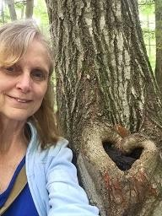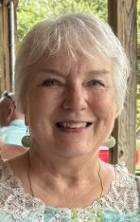

We all have stories
,
tales we'd love to put on paper or

little snippets of our
lives that we want to tell.

Have you ever wondered about the lives of your grandparents, or those further back in your
family tree?

Wouldn't it be fun to hear their stories again?

Once we’re gone, so are our stories
.

This little workshop will

S
how

you

how you can
create your stories to preserve them
long after we're gone
.

Presented by Mary Ellen Humphrey and Robyn Albright,
join us for a fun hour on
Saturday, August
23
rd at 11a.m.

Boomer Tales!

Write Your Own Story

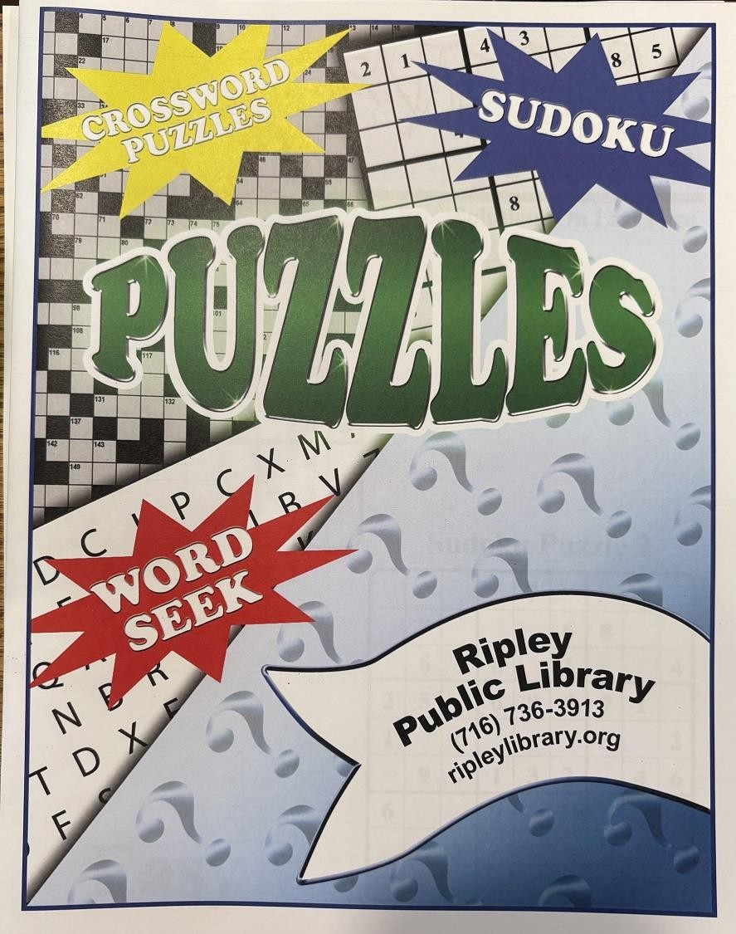

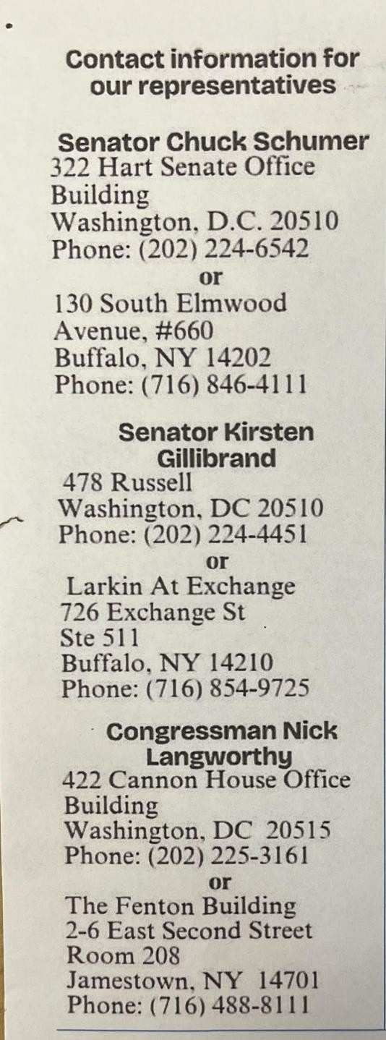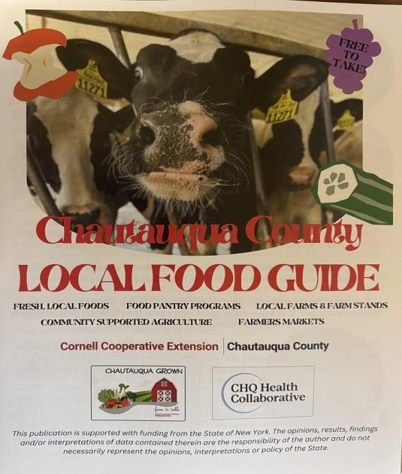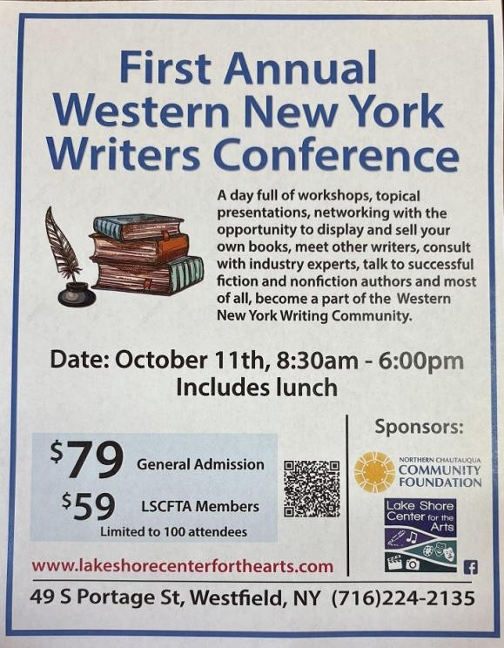
Free at the library

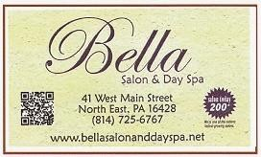
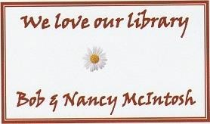
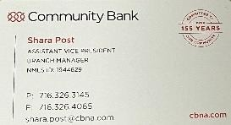
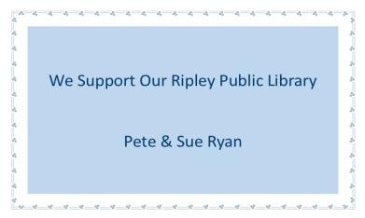
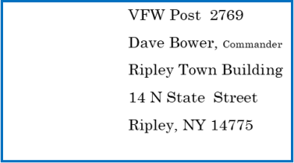

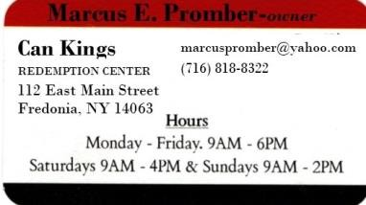
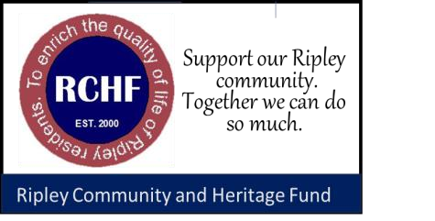
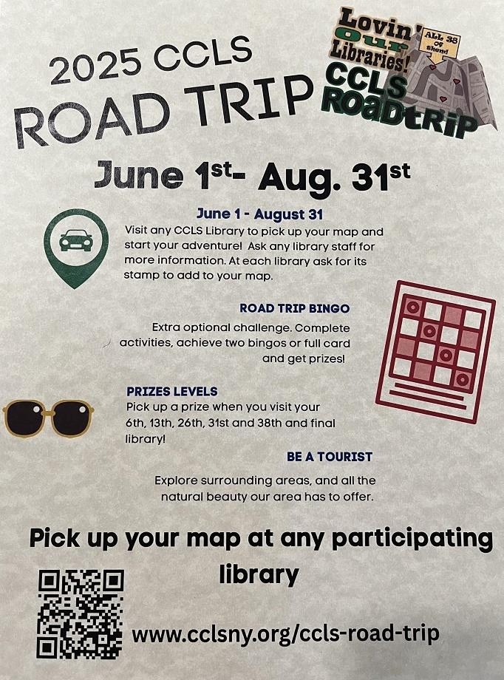

Meetings 4th
Thursday
10:30
a.m.

Local History Book Review  by Michelle Henry, Research Historian  The Fair Chambered Corridor: Explorations of the History of Fredonia, NY  By Douglas H. Shepard, edited by Allyson Shepard Bailey. 2023, Darwin R. Barker Historical Museum.  Doug Shepard was a retired SUNY-  Fredonia professor who spent 25 years researching and writing local history. Doug was a rare gem – his research was comprehensive; he utilized collections held in government archives, history museums, libraries, private collections, and anywhere else that records were made available to him. He was incredibly thorough, and he used his notes to write hundreds of articles about the county’s early settlers, the development of roads and bridges, businesses, churches, and houses in Fredonia, the underground railroad, fraternal organizations, and so much more.  His research is the foundation for the interactive anti-slavery map for the county which is the best tool in New York State for researching the underground railroad. The  map is available at https:// themappingservice.com/project/ugrr.  Doug was generous; always willing to share whatever he found with anyone who was interested. He graciously accepted corrections and suggestions because he was primarily interested in getting things right, not being right. He never sought credit for his work – I think it was his love of doing research that motivated him.  When Dr. Shepard passed away in 2021, his daughter felt, and rightly so, that her father’s meticulously indexed notecards were a treasure that had to be preserved. She had them digitized and deposited at the Barker | Museum in Fredonia so that researchers will continue to reap the benefit of Doug’s work. Additionally, she extracted items from her father’s writings to create an informal history, providing snapshots of the county from its first settlers to about the year 2000. These snapshots are published as The Fair Chambered Corridor, with over 200 pages of interesting and enlightening information plus an exhaustive index. There are illustrations and maps throughout, making it easy to browse through without having to read cover to cover. But a word of caution, you will find that several hours pass each time you pick up this book!  

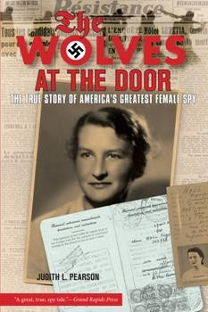
Book Review by Diane O’Brien ture. By the
winter of 1942
The Wolves at the Door: The True
Hall had to
Story of America’s Greatest Female flee France by
Spy
the only way
by Judith L. Pearson possible, a
hike on foot

through the
This is a true story of Virginia Hall, frozen PyreAmerica’s greatest female spy. Her sto- nees Mounry was ignored by history books for fifty tains into neuyears. tral Spain. Upon her re-
Virginia Hall left a comfortable life in turn to EngBaltimore in 1931 to follow her dream land, she was of becoming a Foreign Service Officer. recruited and
After watching Hitler roll into Poland, sent back to France disguised as an old then France, she decided to work for peasant woman. While there, she was the British Special Operations Execu- responsible for killing 150 German soltive (SOE), a secret espionage and sabo- diers and capturing 500 others, sabotage organization. She was deployed to taging communications and directing France where the Gestapo were known resistance activities.
to imprison, beat, and torture spies.
This book is recommended for anyone
Against such ominous backdrop, Hall who has ever been told, “No, you can’t.” managed to locate drop zones for money, helped escaped POWs and downed Allied airmen flee to England. Soon wanted posters appeared throughout France offering a reward for her cap-
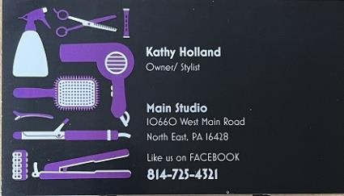
FROM the DESK of the RIPLEY TOWN HISTORIAN
by Doc Hamels

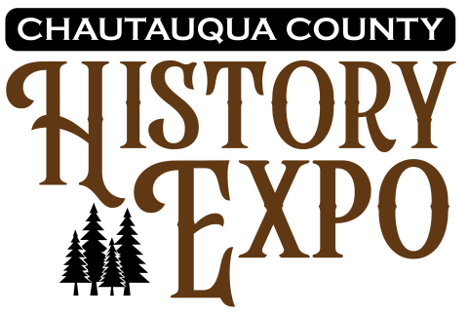
Mission
The mission of the Chautauqua County History Expo is to provide a free and accessible showcase that connects the public with museums, historical societies, municipal historians, libraries, genealogy organizations, and others dedicated to preserving and promoting the history of Chautauqua County and nearby communities.

What is the History Expo?
The Chautauqua County History Expo is a dynamic event designed to showcase the rich history and diverse heritage of Chautauqua County and nearby communities. Organized by the Chautauqua County Historian’s Office and supported by a planning committee composed of representatives from various historical organizations and groups from across the county, this expo aims to promote local history through the active participation of museums, historical societies, municipal historians, libraries, genealogy organizations, local history authors, and other historical entities. Scheduled for August 23, 2025, at the Fluvanna Community Church in Jamestown, NY, the event is free of charge for residents and visitors to the Chautauqua Region. Attendees are invited to explore vendor tables featuring artifacts, displays, books, literature, video presentations, and more. A series of lectures focusing on local and regional history will also take place.

• Featured Vendors :

• Historical Societies • Museums • Genealogical Societies • Lineage Societies • Libraries • Local Historians • Local History Authors

Page 11 Volume 14, August 2025
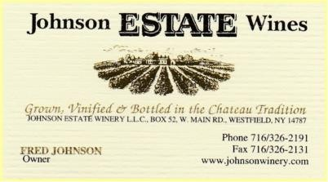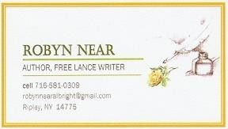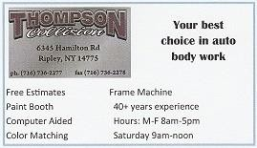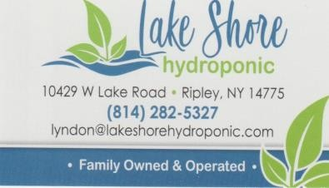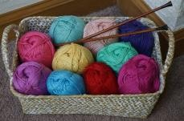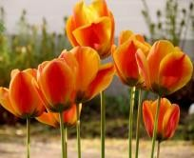
The Best Friends Fund
is Proud
to be a part of the
Ripley Public Library!

Diamond Art
meets
Tuesdays at 4:30 (Dot
Doers)

Trial size available for
free, then purchase the
kits you like.

Sewing Group
meets Thursdays at
noon.

Quilters and sewers
of all levels are wel-
come.

Knitting & Crochet Group
meets
Tuesdays at noon.
All levels welcome.

All the
Best
-

Bill & Pat

Locke

Is there an activity or class you’d
like to see at our library?
Commu-
nity members come here to sew, knit,
play cards, Stay ‘n Play for the little
ones, and meet. The library would
like to offer more for our residents to
do.

There are hundreds of classes online
that we could present here on our
large screen television.

Do the times of offered activities not
fit your schedule? Let us know! We’re
here to enrich your lives.

Come visit the library!

August Book List PAPERBACKS
ADULT FICTION Bartz/The Writing Retreat
Jackson/You’ll Find Out
Alward/When the World Fell Silent Johnstone/On the Royal Range
Bastone/Promise Me Sunshine Swanson/Murder of an Open Book
Bostwick/The Book Club for Troublesome Women
Bradley/The Ministry of Time
Bregman/The Last Hamilton YOUNG ADULT
Brunsetter/The Peacemaker
Davis/Summer at Hideaway Key Albert/The Bad Ones
Ellis/The Neighbor's Cat Cooper/Shackled
Fredrick/29…Again Couch/Another First Chance Harmon/The Outlaw Noble Salt McGinnis/Under This Red Rock

Kamili/The Lion Women of Tehran
Kelley/The Bookshop by the Bay JUNIOR
Neff/The Days I Loved You Most
Read/Go as A River Fipps/And Then Boom!
Stringer/Charity Trickett is not so Glamorous Gilligan/Pluto Rocket: Full Blast
Swift/The Silk Code Kantorovitz/Monti and Leo Taylor/Into the Gray Zone Lowry/Tree. Table. Book.
Thomas/Silverleaf Rapids
Wingate/Shelterwood
Woods/The Mysterious Bakery on Rue de Paris EASY READER

Bee/The Delphino Detectives
LARGE PRINT Breen/Sky & Ty

Hosford/You’ll Always Be My
Andrews/Echoes in the Walls Chickadee
Henderson/The Funny Thing About Norman Kane/ Monster Hands
Foreman
McKinnon/Message in the Sand
Reeves/A Fire in the Wilderness

Fabulous 50 Readers!
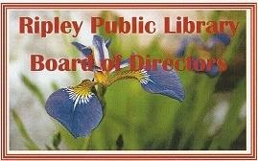
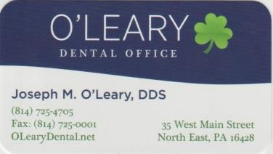
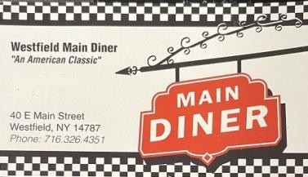
Register for the Fabulous 50 and make sure you fill in books read on the chart at the library to receive your prize. Complete 25 books and receive a prize as well.
Ripley Library is looking for Local Authors  We invite published (including selfpublished) writers to come and speak to our audience, telling us a little bit about yourself and your book. This is generally followed by a Q&A period and a book signing. Call the library and we’ll set up a date. 716-736-3913 |  | Library Cards: Your Passport to Adventure  If you need a library card, come see us and we will help get you into the IN crowd. If you haven’t renewed your card, we can take care of that too!  Welcome to a world of adventure!  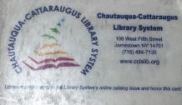

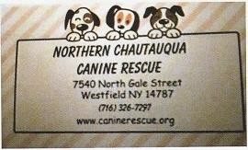
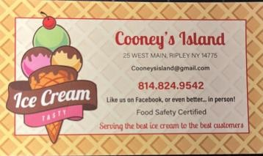
Book Chat  A new Facebook page, sponsored by Ripley Library, hosts adult readers who will discuss their favorite books, and check out new authors.  Ripley Readers Retreat will meet, live, online, every Monday, between 3pm and 7pm.  Check the Ripley Public Library Facebook page for information. |  | Fabulous 50  We invite booklovers everywhere to join. The goal is to read 50 books in a two-year period. For every 25 books you read you will receive a prize.  To enter, register at the library or by phone or email. The list can be picked up at the library or sent to your email. Check off each box as you complete a book and write the name of the book and author. Contact the library every month to let us know what you’ve achieved.
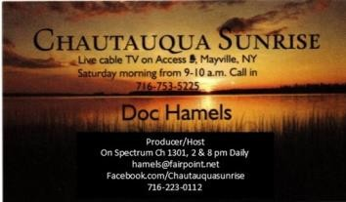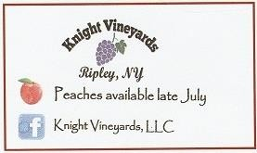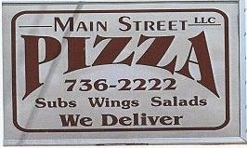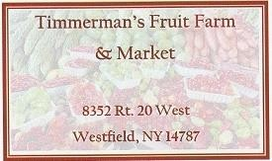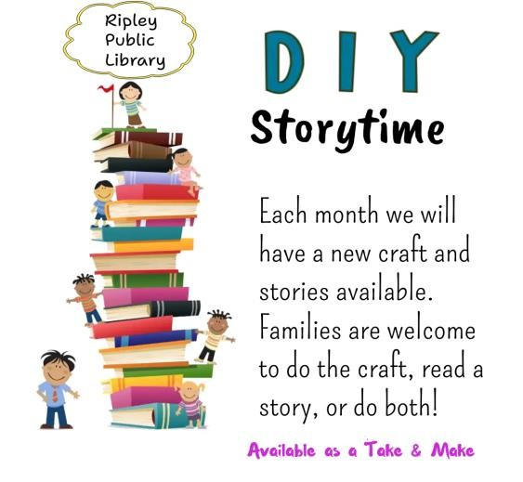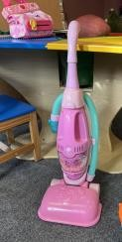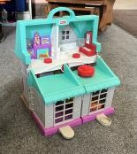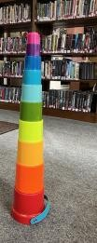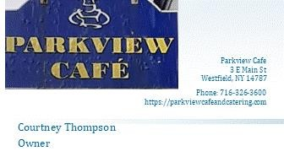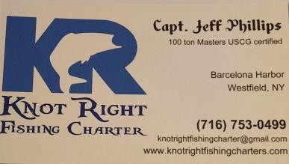
Wanted:

Lego pieces and Lego sets

We will gladly accept any new or used
Lego items to add to our collection.

Please drop them off at the library.

Thank you
.

Need an easy way to donate to the
Ripley Library? Bottle and Can
Collection

The Library has a collection bin in the lobby
for returnable cans and bottles.
Don’t throw out those water bot-
tles and pop cans! Donate them
to the library.

Please be sure all bottles and
cans are empty before you place
them in the bin.

Stay and Play

At Ripley Public Library

Moms and Dads! Every Tuesday at
am
10:30

Bring your Babies and Toddlers age
0
-
years and join us for lots of
4
socializing, fun, toys, books, and
refreshments.

For more details call

716
-
736
-
3913

Page 15
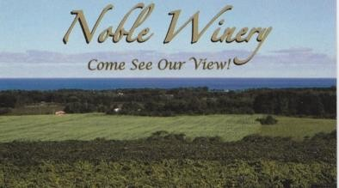  8630  Hardscrabble Road  Westfield, NY 14787  (716) 326  -  9463  sales@noblewinery.com | 
Proud to Support

the Ripley Public Library.
John & Rhonda Thompson

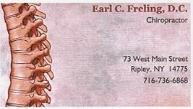

I Love my library

Diane Bentley O’Brien

  Community Table
  The Ripley Public Library welcomes community groups who would like to set up a table in our lobby to promote their business or group. Examples: VFW Poppy sales, Girl Scout cookie sales, as well as distribution of pamphlets or information about your group or activity. A representative for the table must be present for items to be displayed.
  
  Reservations must be made.
  There is no cost, it’s just our way of giving back to the community. 716-736-3913
  Ripley Public Library Has Become a Safe Place Location
  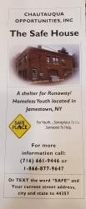
  What is a Safe Place Location, you might ask? A Safe Place works with the Safe House out of Jamestown and is part of Chautauqua Opportunities, Inc. This is a program for runaway or homeless youth under the age of 18. If this young person needs help, all they have to do is enter the facility displaying the yellow sign that reads SAFE PLACE. They let someone in charge know they need help.
Volume 14, August 2025 Page 16

Best Friends of the Ripley Public Library
We Need Your Help!
Ripley Library’s BFF group (Best Friends Fund) is looking for more members to join us to help with fundraising and program support for our library.
Dues are just $5 per year. All we ask is that you attend monthly meetings as often as you can, and occasionally help with fundraising events. Funds raised by BFF are used for library equipment and supplies, upgrades, Summer Reading Program, etc.
There are many things to be proud of in Ripley. Our beautiful library is one of those things. Please call 716-736-3913 for more infor-

Best Friends of the Ripley Public Library
Ripley Library Best Friends Fund Application
Name:____________________________
Mailing Address:___________________________________
Town/ZIP:________________________________________
Phone Number: (Home) ___________ (Cell)________________
Email Address:_____________________________________
Dues are $5 annually in January
Print this portion and return it to the library, or pick up a form at the library desk.

Ripley Public Library Mission Statement

The mission of the Ripley Public Library is to promote life-long learning for all community residents, providing unrestricted free access to all printed and recorded material from its own collection as well as that of the Chautauqua-Cattaraugus Library System. The Library will endeavor to create a community center that provides so much more than information for all of those who ask questions and seek answers.
August Page 17 BEST FRIENDS
Best Friends Fund of Ripley Library
P. O. Box 808
Ripley, NY 14775

https://www.ripleylibrary.org
Phone: 716-736-3913 Fax: 716-736-3923
https://www.ripleylibrary.org
Email: thebookworm14775@gmail.com
 | Notes & Things
  Email Newsletter
  We rely on email to get our newsletter out.
  Each month you will receive 2 emails, The
  Bookworm and About Town. For a monthly copy, send your email address to:
  thebookworm14775@gmail.com
  If you would like to opt out of our mailing, please let us know at
  thebookworm14775@gmail.com
  *Also available—The Bookworm and About Town on the library website https://www.ripleylibrary.org
  "Reading is an exercise in empathy; an exercise in walking in someone else's shoes for a while."
  Malorie Blackman
New Activities & Classes
Is there an activity or class you’d like to see offered at the library? Can you teach a class or give a talk about a topic? Let the library know if there is something new you’d like to add to the many programs and classes already offered. 716-
736-3913

Attend a Board Meeting
Ripley Public Library Board of Trustees meetings are open to the public. Check the schedule in The Bookworm for times and dates.

Ripley Public Library is Open for Business
Mon. Wed. Fri. 10 a.m.-5 p.m.
Tue. Thu. 10 a.m.-7:30 p.m.
Sat. 9 a.m-2:00 p.m.


Ripley Public Library Board of Directors Meetings for 2025
Meetings are open
to the public, in per-
Oct 22 son or via Zoom, and Aug 27 Nov 26 will be held at 6p.m. Sep 24 Dec TBA Dates and times subject to change.

  Please note: all letters and/or emails to the Library and staff MUST be signed. Those without a signature will not be recognized. Names will be omitted, to protect privacy, if published.

